# CS 255 System Design Document Template

## UML Diagrams

## UML Use Case Diagram

### UML Activity Diagrams

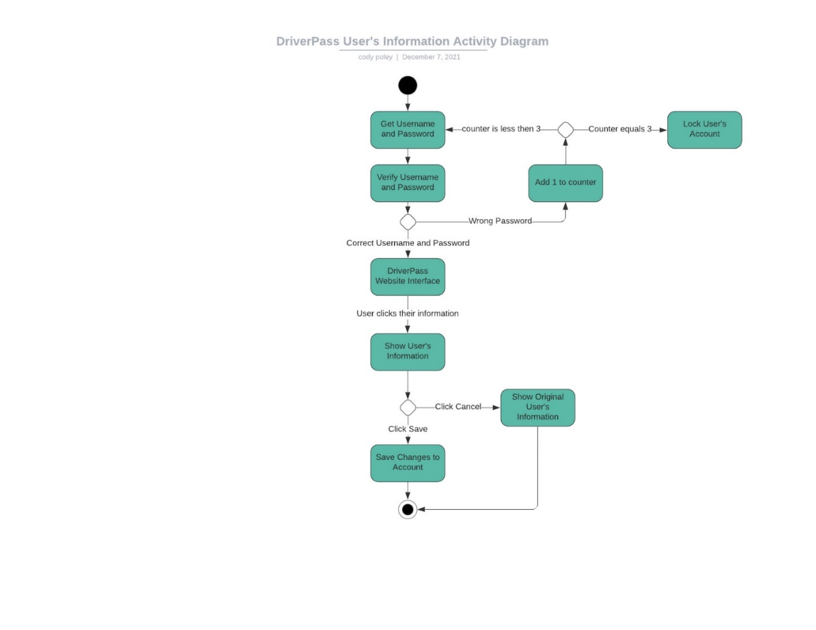

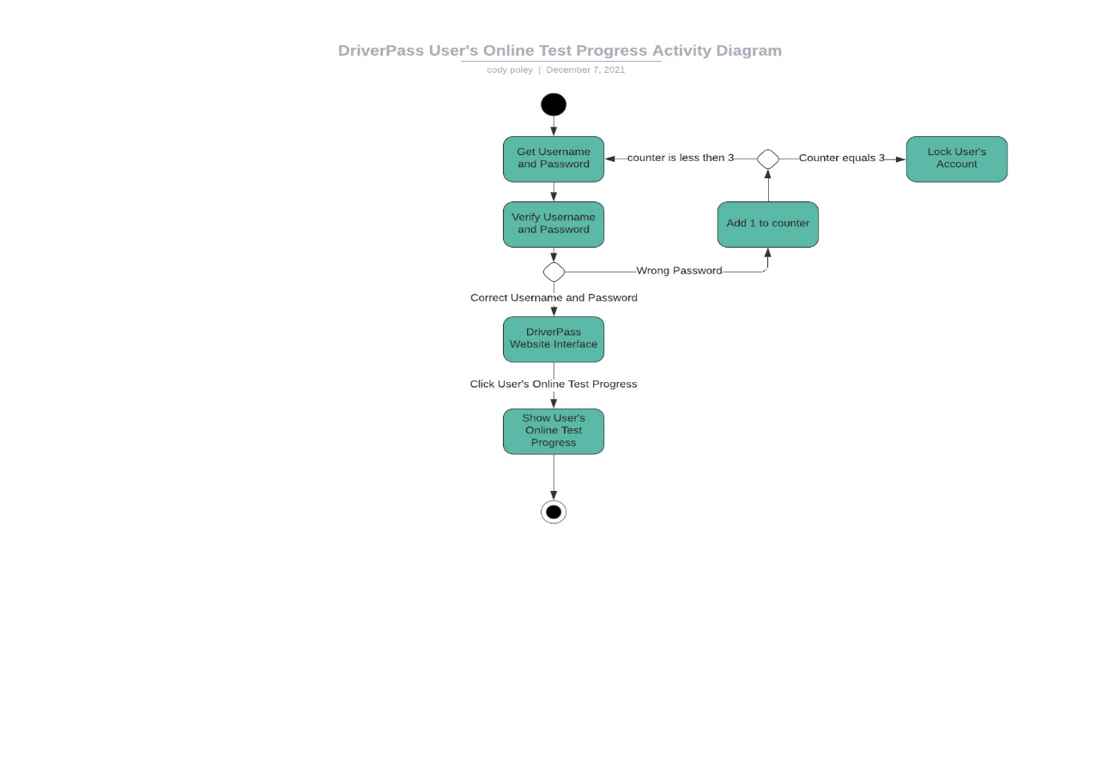

### UML Sequence Diagram

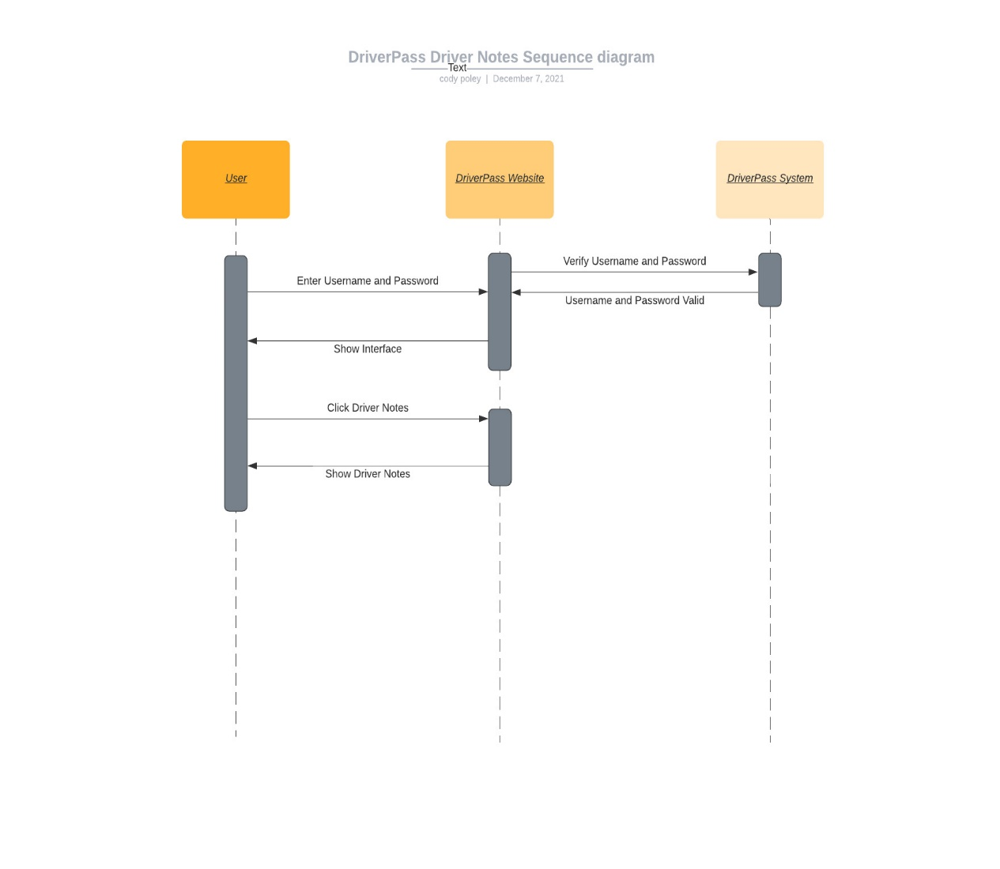

### UML Class Diagram

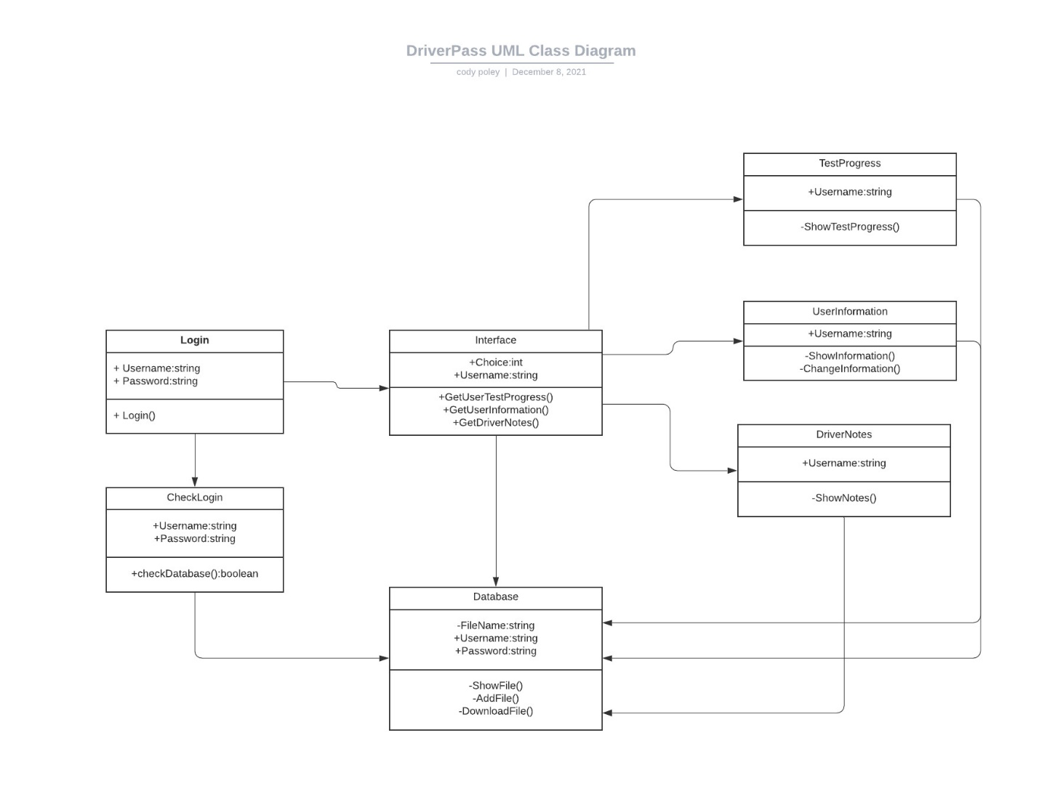

## Technical Requirements

The technical requirements for the DriverPass system to meet the functional and nonfunctional requirements are a Microsoft server, Microsoft Excel, web-based software, and internet connection. The Microsoft server will allow access to the web-based software and the DriverPass database from the internet. Microsoft Excel will be used to for the documentation of the files need for the system. The web-based software will allow the customer and DriverPass to communicate. The internet connection will allow DriverPass and the customers to check their information, make appointments, and reservations.